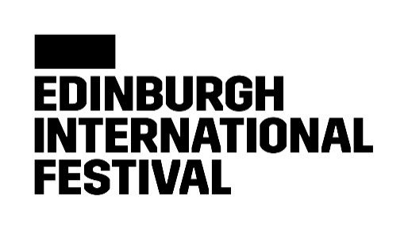

Sir Ian McKellan Bursary Application Form
Awarded by Edinburgh International Festival and Scottish Drama Training Network

Applications should be submitted to Edinburgh International Festival Head of Learning & Engagement Caroline Donald caroline.donald@eif.co.uk This can be submitted in written, audio or video format.
If this is not accessible to you please contact Caroline by email, by phone on 0131 473 2057 or through SignLive.co.uk, our online BSL interpretation service, and we can consider alternative means of application.
All submissions must be in English or British Sign Language.
Personal details
Name: Click here to enter text.
Address: Click here to enter text.
Email: Click here to enter text.
Phone number: Click here to enter text.
Date of birth: Click here to enter a date.
Preferred method of contact:
Phone ☐ Email ☐ Post ☐
Supporting statements
Please provide supporting statements from two people who know you well. One of these must be an academic referee.
Supporting statement 1:
Click here to enter text.
Supporting statement 2:
Click here to enter text.

Questions
Answer the questions below or tick here to confirm you have attached your responses in an alternative format.
Alternative format attached to email ☐
The word count limit for each is 500 words max or if submitting in an alternative format the time limit is 3 minutes total.
What will you gain from your time studying?
Click here to enter text.
Who are you influenced by in the industry and outside the industry?
Click here to enter text.
Why do you need the bursary?
Click here to enter text.
What do you imagine you will ‘give back’ as a result of the bursary e.g. what is your legacy offering
Click here to enter text.

